User: Hi
Bot: Hello, Danny! How can I assist you today?
Bot: Hello! How can I assist you today?
User: /help
Bot: the list of available actions:
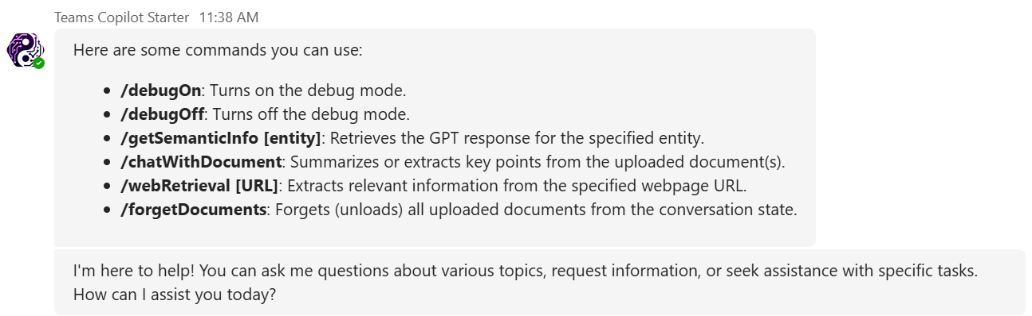
You can ask general questions:
User: When did Albert Einstein develop the theory of relativity?
Bot: 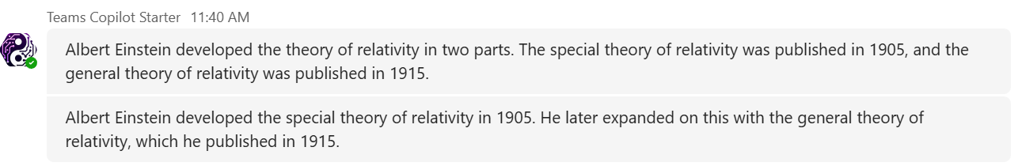

Or ask about the things that require internet crawling:
User: tell me the history of evolution of guitar
Bot: 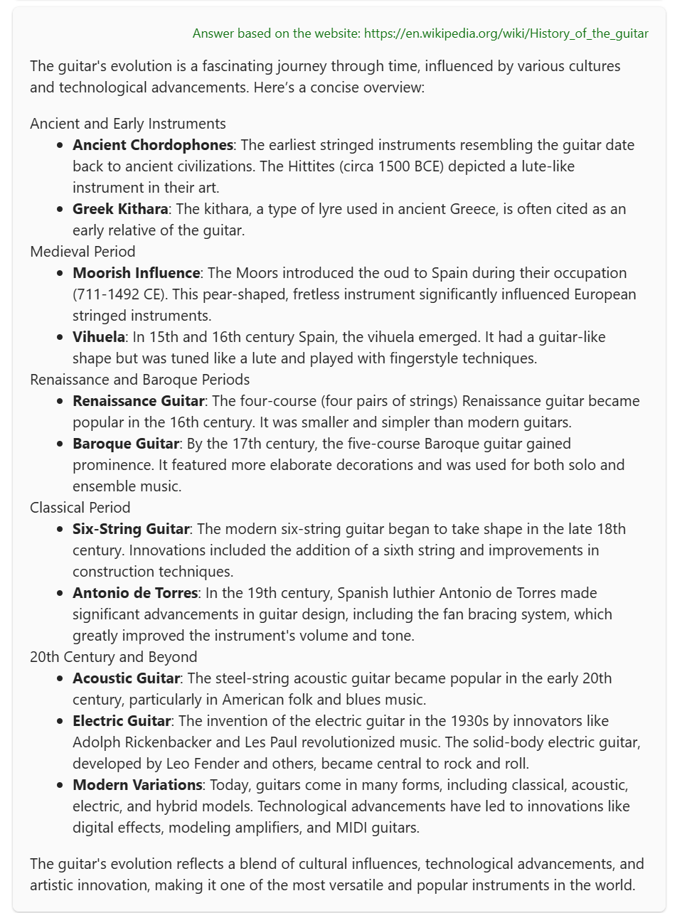
To forget documents that were used in the chat history, simply say:
User: forget documents
Bot: All uploaded documents have been forgotten.
You can also ask about the content of the document(s) that have been injected and indexed by Azure AI Search RAG:
User: Per Pickleball Self-Assessment Rating Guide, what are the characteristics of the player with 3.5 rating?
Bot: 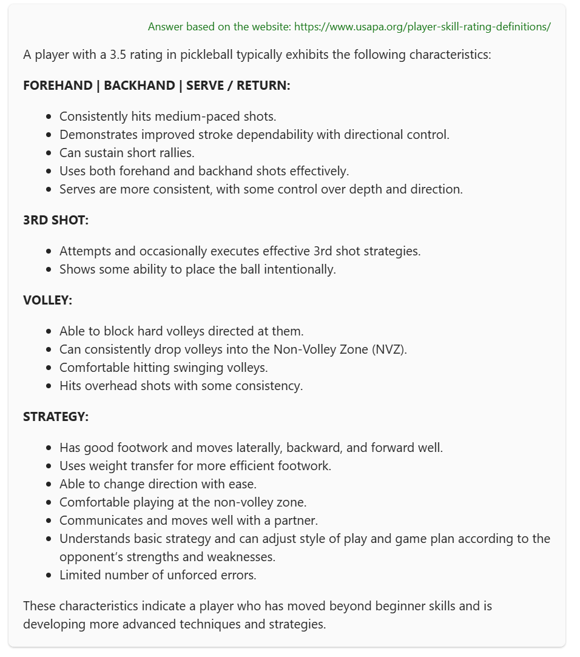
And finally, you can troubleshoot the Bot action mechanics by turning on the debug session:
User: debug on
Bot: Debug mode has been turned on.

Now, try to ask anything:
User: 2+2
Bot will display the action plan and the execution time:
